**Ticket App**

Problem:

I want to board a train from London to France. The train ticket will cost $5.

1. Create an API where you can submit a purchase for a ticket. Details included in the receipt are:  
   a) From, To, User, price paid.  
   (i) User should include first and last name, email address
2. The user is allocated a seat in the train. Assume the train has only 2 sections, section A and section B.
3. An API that shows the details of the receipt for the user
4. An API that lets you view the users and seats they are allocated by the requested section
5. An API to remove a user from the train
6. An API to modify a user's seat

**1. Purchase Ticket:**

**Description: This endpoint is used to purchase a ticket for a user.**

**EndPoint:**

[**http://localhost:8080/api/v1/ticket/purchase**](http://localhost:8080/api/v1/ticket/purchase)

**Method:**

POST

**Request Body:**

Content type: application/json

{

  "departureFrom": "London",

  "destinationTo": "France",

  "user": {

    "firstName": "John",

    "lastName": "Paul",

    "email": "Johnpaul.k@gmail.com"

  }

}

Response:

{

    "firstName": "John",

    "lastName": "Paul",

    "email": "Johnpaul.k@gmail.com",

    "price": 5.00,

    "seatNo": "A1",

    "departureFrom": "London",

    "destinationTo": "France",

    "userId": 1

}

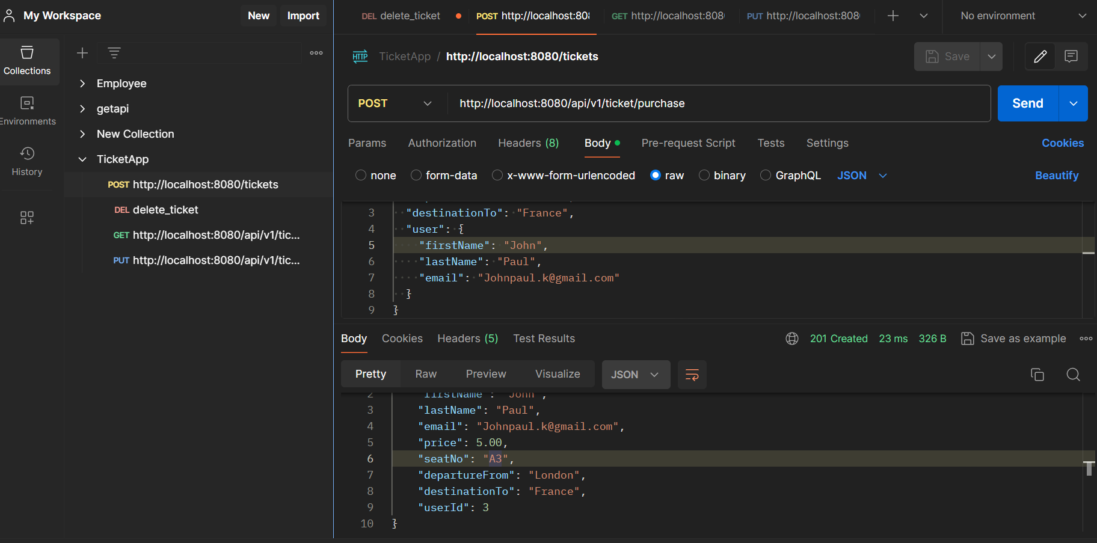

**2. Get Users by Section**

**Description: This endpoint retrieves a list of users who have tickets in the specified section.**

**EndPoint:**

[**http://localhost:8080/api/v1/ticket/users?section=A**](http://localhost:8080/api/v1/ticket/users?section=A)

**Method:**

GET

**Parameters: section (required) The section of the train where the users' seats are located.**

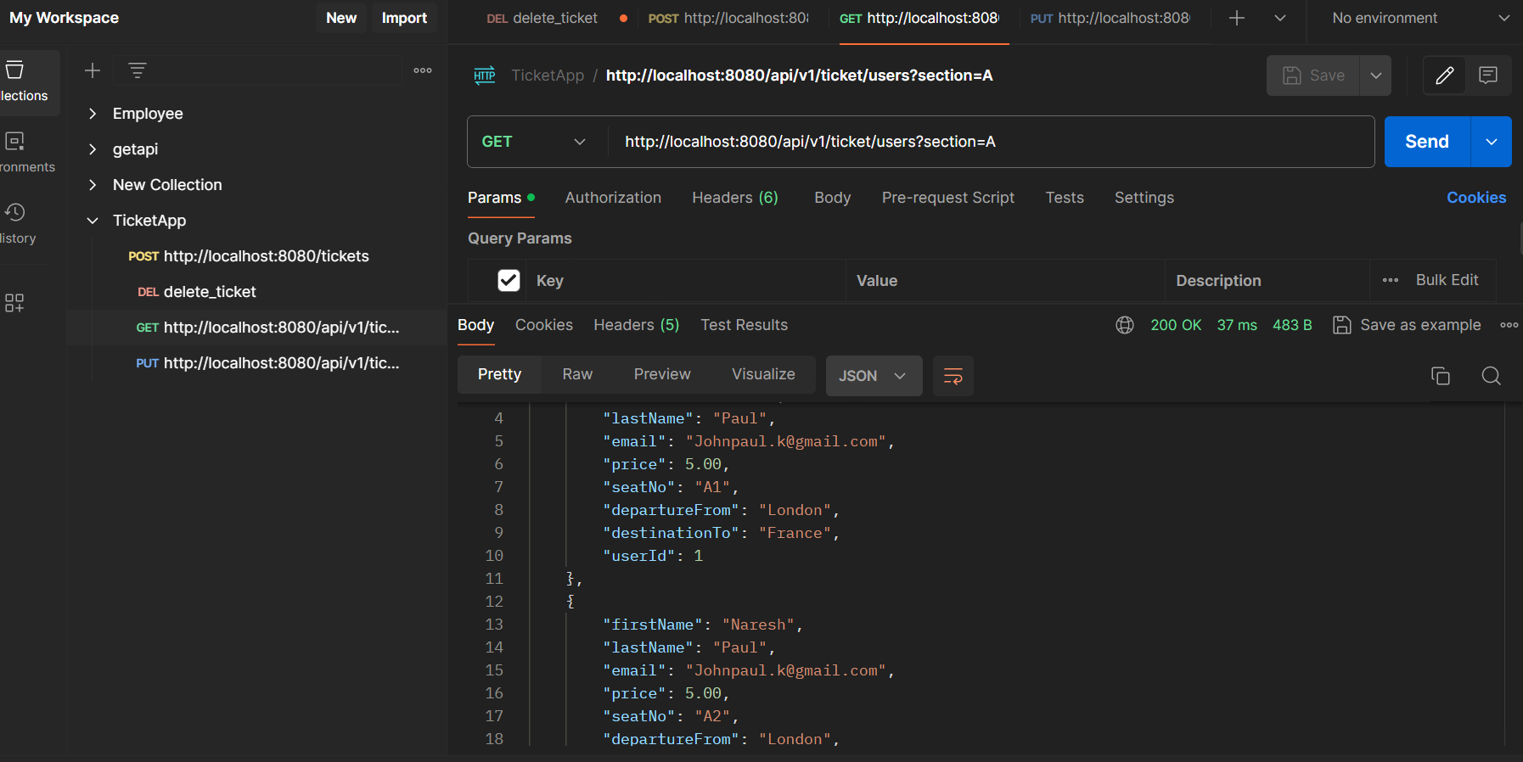

**3. Remove User From the Train**

**Description:**

**This endpoint allows administrators to remove a user from the train based on their user ID.**

**Method:**

**DELETE**

**Endpoint**

**http://localhost:8080/api/v1/ticket/users/{userId}**

**Path Parameters**

**userId (required): The unique identifier of the user to be removed from the train.**

**Response:**

**Status Code: 200 OK**

**Description: Indicates that the user was successfully removed from the train.**

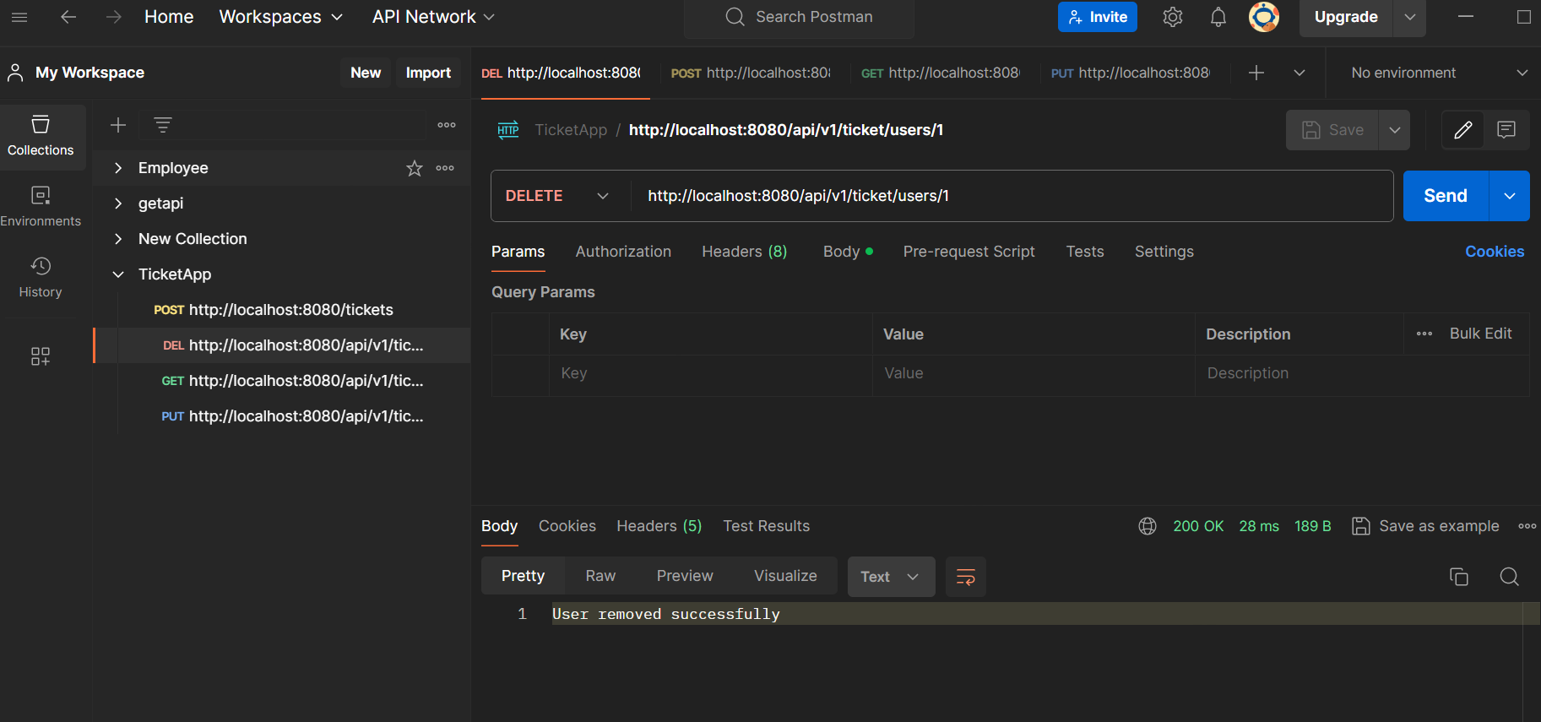

**4. Modify User's Seat**

**Description:**

**This endpoint allows administrators to modify a user's seat on the train based on their user ID.**

**Method**

**PUT**

**Endpoint**

**http://localhost:8080/api/v1/ticket/users/{userId}/seat?newSeat={newSeat}**

**Path Parameters**

**userId (required): The unique identifier of the user whose seat is to be modified.**

**Query Parameters**

**newSeat (required): The new seat designation to be assigned to the user.**

**Response**

**Status Code: 200 OK**

**Description: Indicates that the user's seat was successfully modified.**

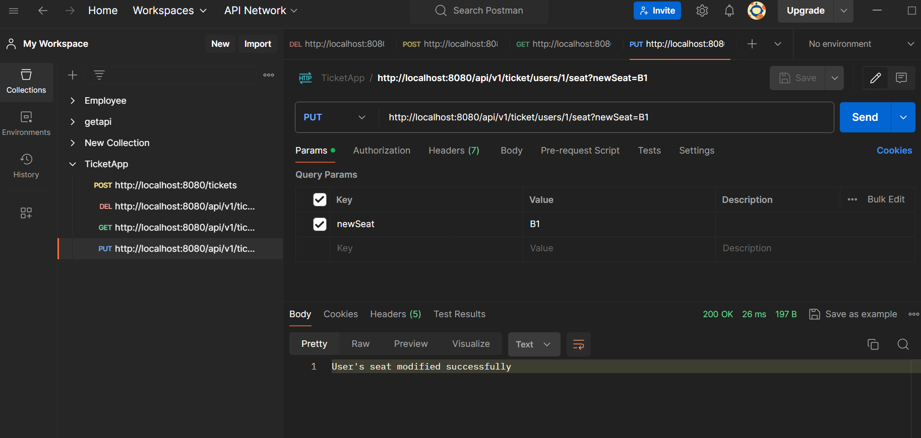

**Note:**

**Before starting the end points execution please run the below scripts in h2 memory db.**

**INSERT INTO SEAT_INFO (SEAT_NO, SECTION, PRICE, STATUS)**

**VALUES**

**('A1', 'A', 5.00, 'Available'),**

**('A2', 'A', 5.00, 'Available'),**

**('A3', 'A', 5.00, 'Available'),**

**('A4', 'A', 5.00, 'Available'),**

**('A5', 'A', 5.00, 'Available'),**

**('B1', 'B', 5.00, 'Available'),**

**('B2', 'B', 5.00, 'Available'),**

**('B3', 'B', 5.00, 'Available'),**

**('B4', 'B', 5.00, 'Available'),**

**('B5', 'B', 5.00, 'Available');**

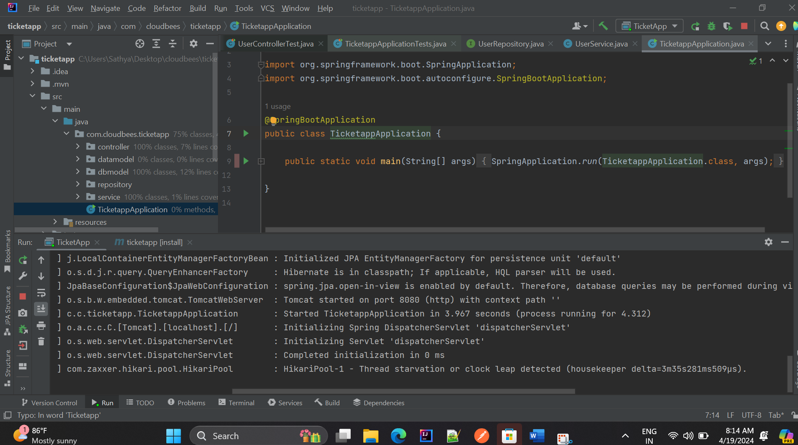

**Testcases result:**

